Test data

Accessed through: <http://ec2-52-43-249-215.us-west-2.compute.amazonaws.com/Test_files/login_form.html>

Tables created:

Queries used to display all of the tables entries



OutPut:

Account table

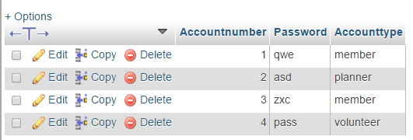

Member table

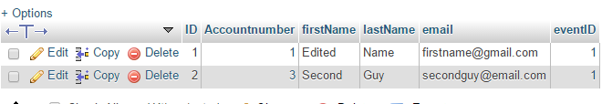

Planner table

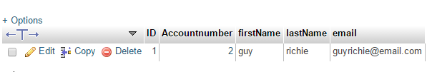

Volunteer table

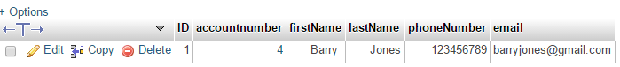

Queries used (and other ways) to insert test data

